1. **Mounting of height sensor**

In this chapter, we explain how to connect the sensor to the board on Quadcopter.

* 1. **Pin Connections of Altitudesensor**

The pins on sensor are shown below.

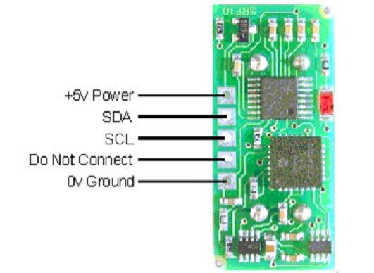

A 10-pin connector is used to connect sensor to Quadcopter.

|  |  |
| --- | --- |
| Pin#  (from right hand side) | Input and output signals |
| 1 | 5V |
| 3 | SDA(I2C-Data) |
| 5 | SCL(I2C-Clock) |
| 7 | Do Not Connect |
| 9 | 0V Gnd |

* 1. **Pin Connections of Board**

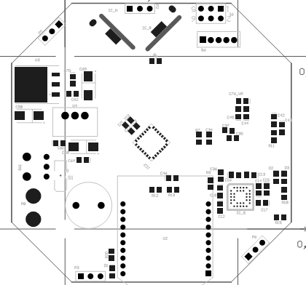

**yellow PPM**

**red +5V**

**brown GND**

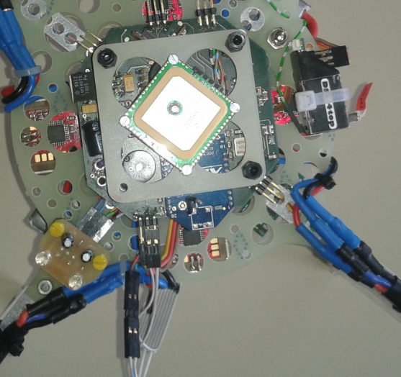

**SCL(wire with blue stripe)**

**SDA (wire with red stripe)**

**GND**

**+5V**

1. **Software for height sensor**

In order to get measured data from the sensor, some codes are added in to the project.

* 1. **Including QH_heightsensor.h & QH_heightsensor.c**

Some important functions are shown in the table below.

|  |  |
| --- | --- |
| heightsensorSetRange(uint8 range) | Set the maximum range of the SRF10 sensor by adjusting the time the sensor waits for an echo. The higher the range, the longer the time needed for measuring. Maximum time is 65us.  - range: defines the maximum range in cm, theoretical maximum is 10m, max range of the sensor about 6m  Return value: 0 for invalid values of range, 1 for valid values. |
| bool heightsensorSetGain(uint8 gain) | Set the gain for the SRF10 sensor. It is saved in the ram of the sensor.  This value must be set while initializing the sensor!  - gain  Return value: 0 for invalid values of gain, 1 for valid values. |
| uint16 heightsensorGetHeight(void) | Get the height of the Quadrocopter in cm. Return value: height in cm. |
| void heightsensorInit(void) | Initialize the gain and range of sensor. |

* 1. **Change in copter.h**

This file contains structs describing the copters actual state.

The height of the copter should be added.

Struct CopterState

/* Ultrasonic Sensor*/

uint16 altitude;

* 1. **Change in main.c**

The main.c contains the starting point of the software.

The functions of SRC10 Library should be included in the project.

#include “QH_heightsensor.h“

Function heightsensorGetHeight() which is called every 200ms gets height and then saves the measured height into the CopterState.

/* functions, called every 200 milliseconds */

if (timerIsFlagSet(TIMER_FLAG_200MS))

{

copterGetStatePtr()->altitude = heightsensorGetHeight();

}